Lab 2 Part 4

Create an Android Project “Lab 2 Part 4” and make the following UI:

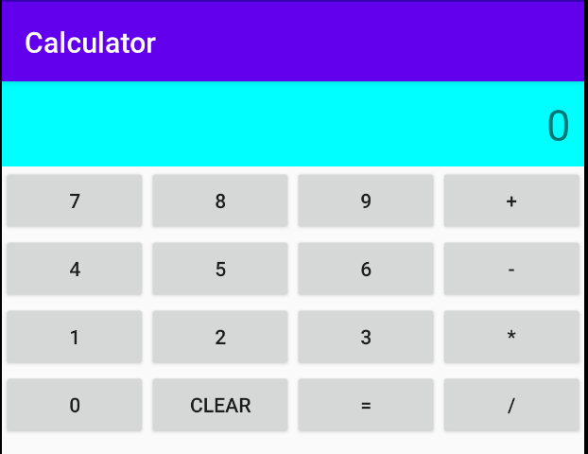
  id/tV1
  id/btn7 | id/btn8 | id/btn9 | id/btnPlus
  id/btn4 | id/btn5 | id/btn6 | id/btnMinus
  id/btn1 | id/btn2 | id/btn3 | id/btnTimes
  id/btn0 | id/btnClear | id/btnEqual | id/btnDiv

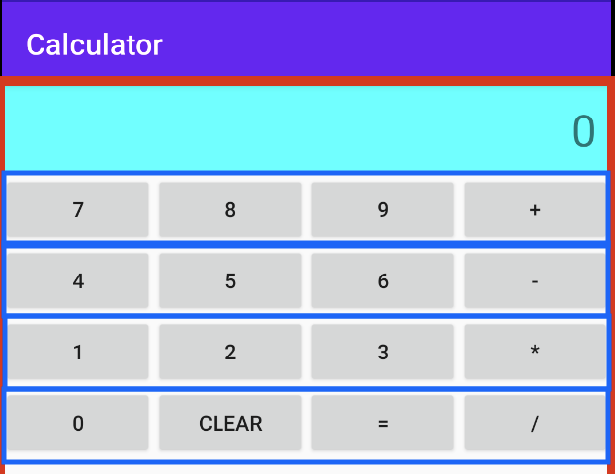 | Hints:  Set a vertical LinearLayout for the whole screen.  Set 4 horizontal LinearLayouts for  btn7, btn8, btn9, btnPlus  btn4, btn5, btn6, btnMinus  btn1, btn2, btn3, btnTimes  btn0, btnClear ,btnEqual,btnDiv

For “tV1”,

set layout_width to match_parent, and layout_height to wrap_content

set background color to 00FFFF

set text size to 30sp, padding to 10dp, and align text to the right

For ALL of the other buttons, set the layout_width to 0dp and layout_weight to 1

- Type the following code in build.gradle(Module:app) and click “Sync”

  - implementation 'com.faendir.rhino:rhino-android:1.5.2'

- Here is the code about Rhino:
org.mozilla.javascript.Context rhino = Context.enter();
rhino.setOptimizationLevel(-1);
String finalResult = "";
try {
Scriptable scriptable = rhino.initStandardObjects();
finalResult = rhino.evaluateString(scriptable,progress,null,1,null).toString();
}catch (Exception e){
finalResult="0";
}

